Homework 1
(Due 24th September in class)
Note: The first two problems are for practice purpose, will not be graded. You can work in a group of two students.
- Consider the following circuit
- What is the logic function implemented by the CMOS transistor network? Size the NMOS and PMOS devices so that the output resistance is the same as that of an inverter with an NMOS W/L = 4 and PMOS W/L = 8.
- What are the input patterns that give the worst case t_{pHL} and t_{pLH}. State clearly what the initial input patterns are and which input(s) has to make a transition in order to achieve this maximum propagation delay. Consider the effect of the capacitances at the internal nodes.
- Verify part (b) with Cadence Spectra. Assume all transistors have minimum gate length and you are allowed to run the simulations in any technology node starting from 130 nm and below.
Answer 3) a.
Also we consider the length of transistor equal to minimum length size in 65nm technology:
For NMOS transistors since A and B are parallel and C and D are stacked on each other, also the parallel of A and B is stacked with C and D we have:
On the other hand according to the problem we have:
For the PMOS network, A and B are stacked and C and D are parallel. Also the branch of the A and B is also parallel with C and D. So we have:
The equivalent transistor size for PMOS network when only one branch is active can be calculated as:
On the other hand according to the problem we have:

Therefore:

For NMOS transistor:
For PMOS transistor:
Answer 3) b.
- High to Low Delay
Considering 0 = Logic Low and 1= Logic high = VDD in this problem,
The worst High to Low delay (t_{pHL} ) occurs when A=0, B=1, C=1 and D switch from 0 to 1.
That is because first, for High to Low transition at least one path from output node Y to GND with all transistors in ON region is required (After transition of D, those transistors connected to B, C, D are ON and make this path). Second for the maximum delay only one path from output node Y to GND with all transistors in ON region should exist. Third, when A=0, B=1, C=1 and D=0, those transistors connected to B and C in N network and the transistor connected to A in PMOS network are ON and the transistor connected to D in N network is OFF, as a result all the internal capacitance are connected to VDD through ON transistors and these capacitors are charged to VDD. When D switch from 0 to 1 all these internal capacitance should be discharged through the path consist of NMOS transistors connected to B, C and D.
Also we can say that, since input D in NMOS network has more distant to output node Y it is the slowest input.
- Low to High Delay
The worst Low to High delay (t_{pLH} ) occurs when A=0, B=1, C=1 and D switch from 1 to 0.
That is because first, for Low to High transition at least one path from output node Y to VDD with all transistors in ON region is required (After transition of D the PMOS transistor connected to D becomes ON and make this path). Second for the maximum delay only one path from output node Y to VDD with all transistors in ON region exists. Third, when A=0, B=1, C=1 and D=1, those transistors connected to B and C in N network and the transistor connected to A in PMOS network are ON, as a result all the internal capacitance of all internal nodes are connected to GND through ON transistors and these capacitors are discharged to GND. When D switch from 1 to 0 all these internal capacitance should be charged to VDD through the path consist of PMOS transistors connected D.

Answer 3) c.
In the following figure the schematic of the circuit in cadence software is shown.
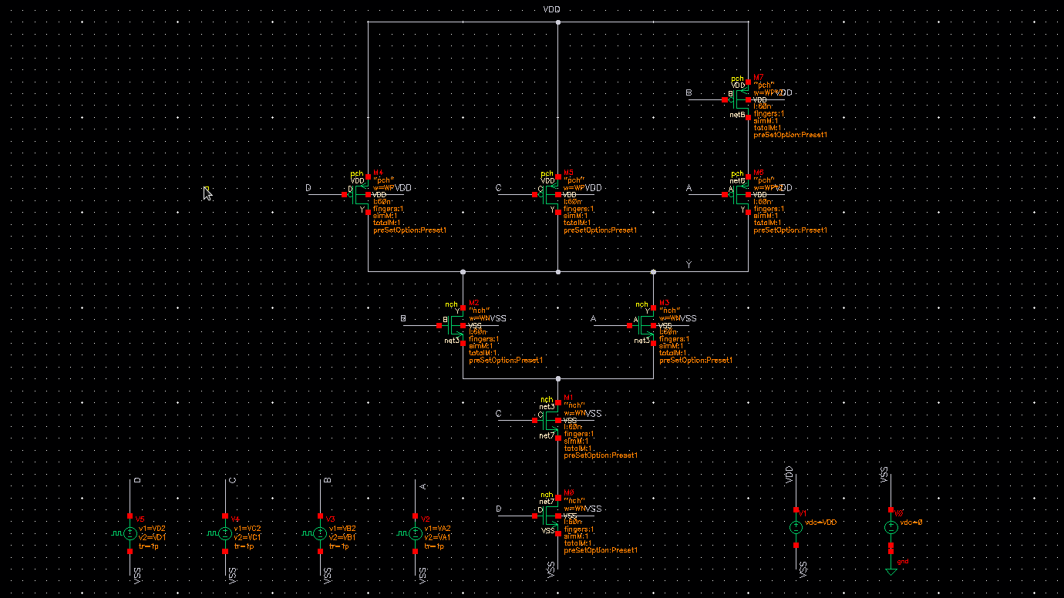
Simulation result of the circuit for 3 different input patterns which cause output high to low transition are shown below:
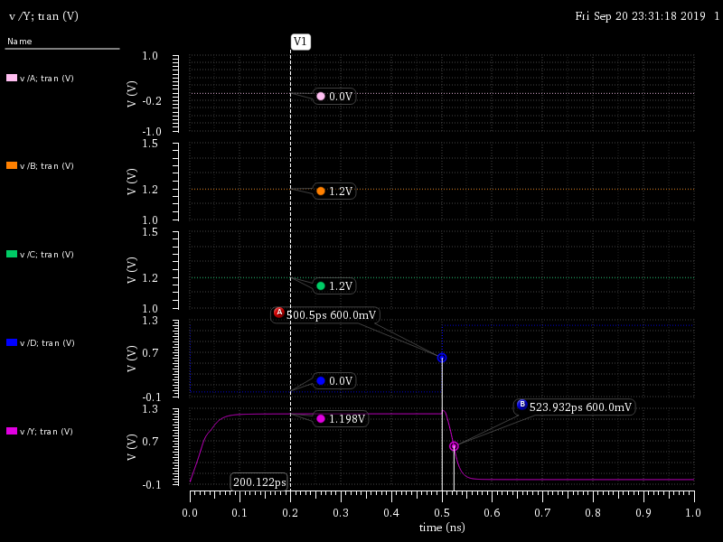
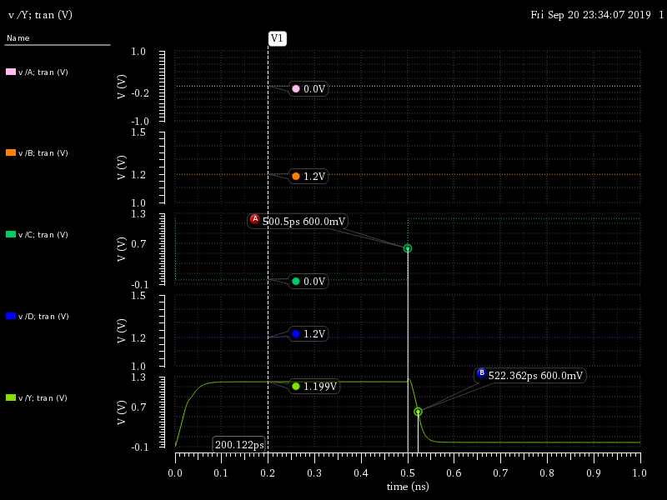
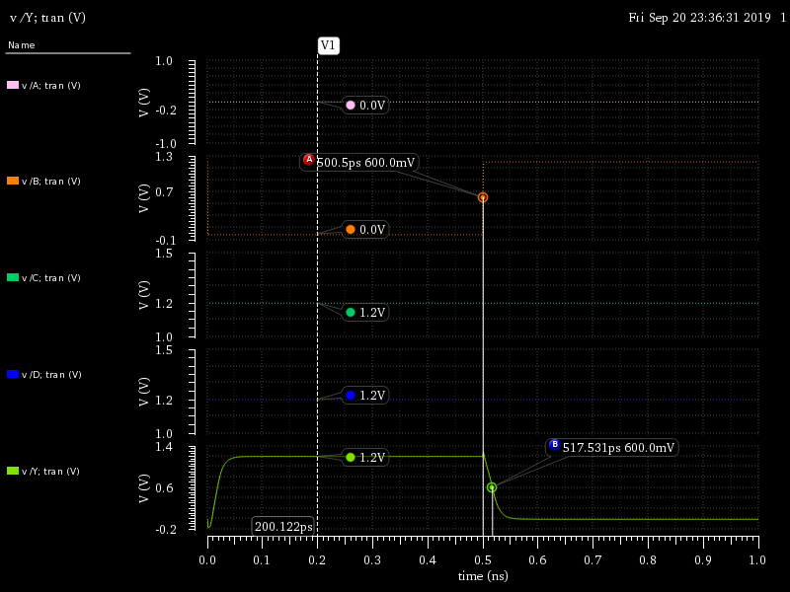
As we can see when A=0, B=1, C=1 and D switch from 0 to 1, the high to low delay is maximum which is 23.93 ps.
Simulation result of the circuit for 3 different input patterns which cause output low to high transition are shown below:
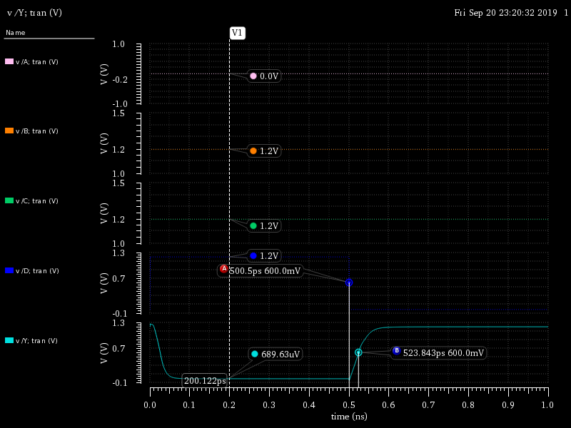
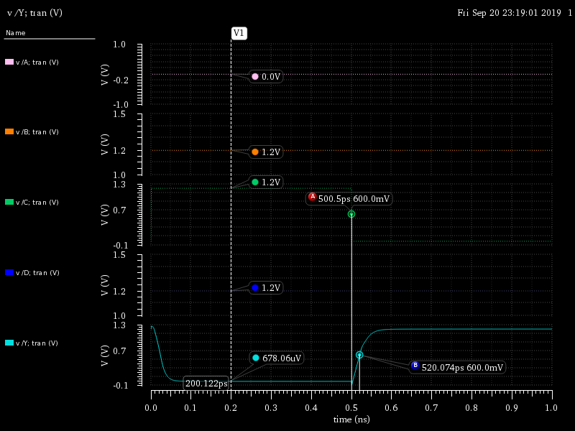
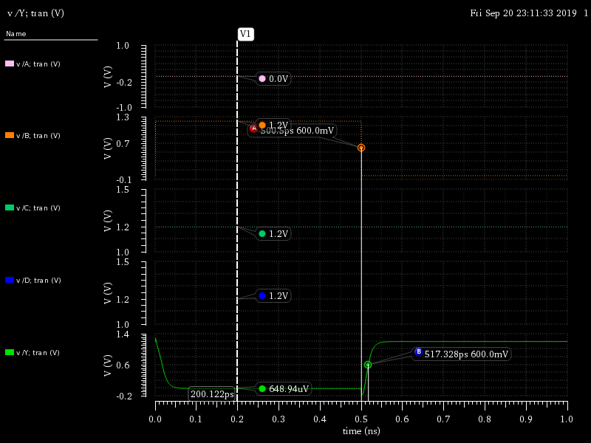
As we can see when A=0, B=1, C=1 and D switch from 1 to 0, the low to high delay is maximum which is 23.84 ps.
- Consider the following two circuits
- Do the following two circuits implement the same logic function? If yes, what is that logic function? If no, give Boolean expressions for both circuits.
- Will these two circuits’ output resistances always be equal to each other?
- Will these two circuits’ rise and fall times always be equal to each other? Why or why not? (Demonstrate through Cadence simulation)
- What input patterns (A–E) give the lowest output resistance when the output is low?
- What input patterns (A–E) give the lowest output resistance when the output is high?

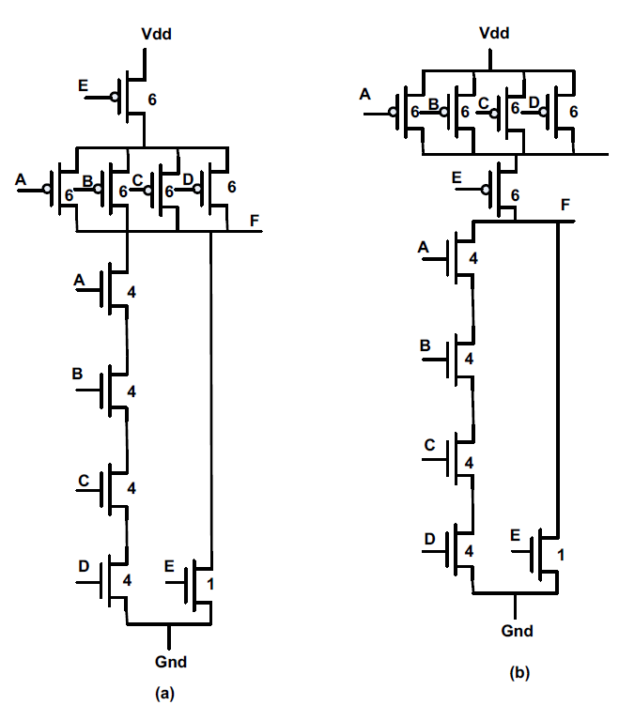

Answer 4. (a)
Both structure have the same logic Boolean expression. The logic function of them is:
Answer 4. (b)
Since both circuits have same logic function and also corresponding transistors in both structures have the same size, the output resistor of the both circuit are equal for all possible input patterns.
Answer 4. (c)
These two circuits have different rise time and fall time. That is because although the output resistance of both circuits are equal, the nodes capacitors which are charged to VDD or discharged to GND during rise time or fall time are different due to different input pattern. For example, when A=B=C=D=0 and E switches from 0 to 1 the output changes from 1 to 0 but the total capacitor which is discharged to GND is different and it is also a function of A, B, C and D input. In the following figure it seems that high to low delay of the output of the structure (a) that is F_a is around 52ps while the high to low output of the structure 9b0 that is F_b is 12ps which shows that structure (a) is much slower than (b) when A=B=C=D=0 and E switches from 0 to 1. That is because of the effect of internal capacitor of the PMOS network which has been seen in case (a) but it does not have any effect in structure (b) when PMOS transistor connected to E isolated the output nodes fron that internal node. In the following figure we see similar occasion for low to high delay as well because of the same reason.
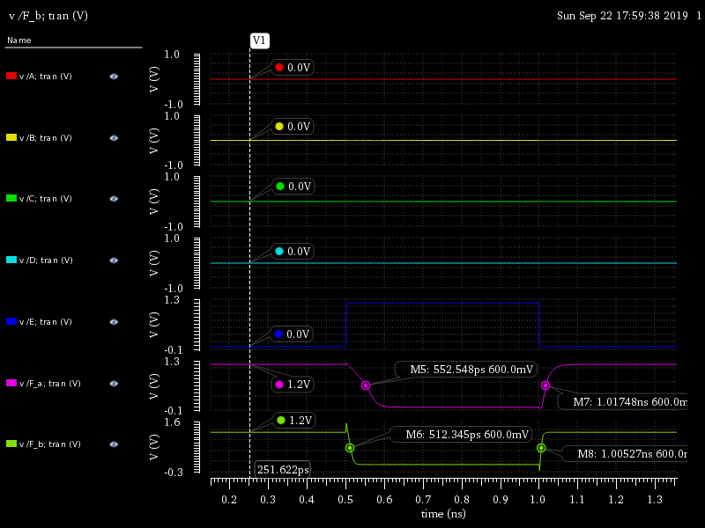

Answer 4. (d)
When the output is low the PMOS network is fully OFF so it does not have any impact on the output resistance. That means the lowest input resistance for output low case occurs when the NMOS network has lowest resistance and it happens when all NMOS transistors are ON.

A=B=C=D=E= VDD and consequently all NMOS transistors are ON.
In this case the NMOS network is equal to an NMOS with W=1/2.

Answer 4. (e)
When the output is high the NMOS network is fully OFF so it does not have any impact on the output resistance. That means the lowest input resistance for output high case occurs when the MOS network has lowest resistance and it happens when all PMOS transistors are ON.

A=B=C=D=E= 0 and consequently all PMOS transistors are ON.
In this case the NMOS network is equal to an NMOS with W=24/5.

